Brief: Artist to deliver shop shutter mural on Upperthorpe
- Context
The Council’s Economic Recovery Fund (ERF) was developed to help mitigate and stave off the worst impacts of the Covid pandemic on the city’s high streets. It asked local businesses and communities to come together and identify the interventions they wanted to see in their areas.
The Infirmary Road project was awarded funds to deliver a programme of streetscape improvements. Part of this project is the ambition to create an exciting and appropriate set of street art installations. This brief is to inform potential suppliers who may be asked to commission to deliver this element of the project.
We hope the project will bring interest to the area, with the art enhancing the wellbeing of local residents, bringing increased footfall to the areas surrounding Infirmary Road and Upperthorpe. This is the key outcome of this work.
- Brief
The area around Upperthorpe and Infirmary Road is a vibrant area of Sheffield with a rich history and a busy high street. It’s home to a major Tesco superstore as well as a number of national chains - including Wynsors a major footwear retailer.
An Arts Trail was created in Walkley and Upperthorpe as part of the first phase of the council’s ERF project.
We now want to extend the project and opportunity exists for further shop shutter mural in Upperthorpe. This piece of work is to create a mural to cover Pillar Nursing’s shutter on Upperthorpe (see premises below). A similar artwork was done nearby in phase one of the project at Pizza Paz (see below)

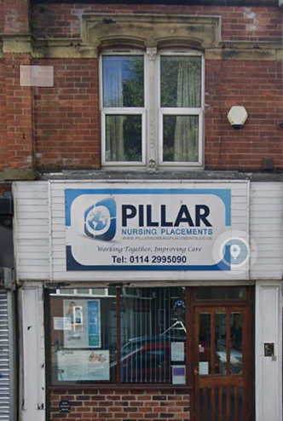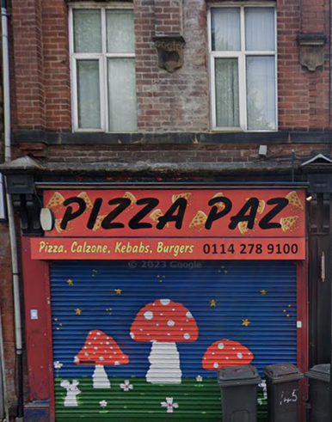

We want to commission artists with experience of outdoor work and request they consider the following in their applications:
- Importance of community focused design: That applicants develop appropriate designs working alongside stakeholders – complimenting the existing arts trail which has the flexible theme of nature/home.
- Preparation: That thorough preparation and priming of surfaces to be painted will help ensure greatest longevity of the work.
- Production/delivery: That the actual creation of the artwork includes consideration of site/safety management, ensuring the use of appropriate paint and weather protection techniques, the use of appropriate traffic or pedestrian management where needed, provision of equipment that may be required, sealing and finishing with a recognised graffiti proof paint and the protection of existing street surfaces from spills and splashes that may be incurred during creation of the work.

- Budget
A maximum of £1000 (inc. VAT) has been identified for this artwork, which should include all artist fees, management, materials and equipment. This is a maximum and responses will be judged on their value for money as well as the quality of their response.
The response should set out your budget for this work and include the following (and any other relevant) budget lines:
- Production of work
- Paint and materials
- Site and safety management
- Project management and fees (including anticipated time on this project)

- Parameters
- Artists should use the theme of nature /home as basis for their designs to complement existing Arts Trail work
- Artwork must be generic and not be seen as representative of the business the shutter covers
- Artists must agree in principle to be available to maintain the work if called upon to do so
  - A ‘maximum maintenance fee’ of a further £100 will be made available to artists, if required, to carry out small touch up works in the future on the basis of two £50 return visits
  - Judging by success and respect given to previous artworks we don’t anticipate touch ups will be required

- Timescales and project management
We would like the work to take place as soon as possible. We are however mindful of weather hinderances but would expect work completion no later than the end of September.
Your work will be overseen by the project team that includes local city councillors and local stakeholders.
- Application process
Artists should submit their expression of interest form by Friday June 28th 2024 via email using the following subject line:
Brief: Shop Shutter Mural application
to communications@zestcommunity.co.uk
Providing the following information:
- Relevant experience
- Your design approach and any initial ideas
- How you envisage managing the practicalities of production – including health and safety considerations, risk assessment, public liability insurance certificate, traffic or pedestrian management
- Budget
- Confirmation and specification of your availability with expected start and completion dates for this work to be carried out through summer (July/August/September 2024). Note: Applications with early availability may be given preference.
- You may include links to or images of select examples of your past work
Applications will be considered by the project team and scored using standard criteria that assess value for money, quality and availability. The quality of applications will determine the successful applicant.
IMPORTANT NOTE: successful applicants will be required to submit their design for approval before any work can begin.
Should you have any queries about this brief or the application process please contact communications@zestcommunity.co.uk in the first instance.

If you don’t already have the relevant expressions of interest form they can all be found on our website

