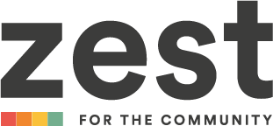
Arts Trail Shop Shutter - Expression of Interest (EOI)

1.Please tell us about your idea/design and how it fits the brief? (max 400 words)

2. Budget (please see project brief for guidance)

3. Please explain how you envisage managing the practicalities of production – including health and safety considerations and risk assessment, insurance, and pedestrian management plans

4. Please provide your availability for this work alongside a project plan with key milestones/dates

Please feel free to add examples of your past work to your application

For any queries or support completing this form, please email communications@zestcommunity.co.uk
Please submit this expression of interest form by June 28th using the following subject line: Shop Shutter Mural application to communications@zestcommunity.co.uk

